SAFETY TIPS

From Selena’s Landscape, Design & Tree Service

Do-It-Yourself Safety Saving Tips
Safety is a very important aspect of performing DIY. It is important to always take the necessary precautions prior to beginning any DIY or plumbing project to ensure that injury is avoided. If you are ever in any doubt, or feel like you cannot undertake the task, then an electrician, plumber or relevant HVAC contractor should be sought for the job.

Electrocution While Doing Your Own Wiring
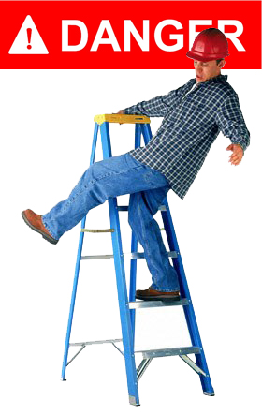
When performing any work with wiring it is very important to turn off all of the electricity in the house. Failing to take this simple measure could result in electrocution. This could be anything from a minor electric shock to a fatal injury. If you are planning on changing or fixing wires yourself then always make sure you take this crucial step.

Falling From A Ladder While Cleaning Your Gutters
Improper ladder use is very common. Before cleaning a gutter it is important to check the state of the ladder prior to climbing it. You should always check to make sure that the ladder is attached together properly and that there are no missing or loose screws that could cause it to fail. Before you begin to climb, make sure that the ladder is secure by lightly jumping on the first step. One of the most common mistakes people make is in having excess baggage, perhaps in the form of a bag, tool belt, or anything that is not required to complete the job. Excess baggage could cause you to lose balance and fall, so it is important to remove anything that you do not need before you start to climb up the ladder.

Asphyxiation From Improperly Connecting Gas Lines
Gas can be very dangerous as it cannot be seen and can be difficult to detect. It is always important to make sure that a trustworthy carbon monoxide detector is installed to ensure that poisoning does not occur. If you are ever in any doubt when connecting gas lines, or if you suspect that there is a gas leakage, then call a professional in order to avoid the possible fatal risk of asphyxiation.

Injury or Death from Tree or Branch Removal
To avoid falling from trees, or having to use a ladder, branches should be lowered to the ground with a rope. It is much safer to use this method than tampering with branches at excessive heights. Ropes can be thrown over large branches which can then be lowered using the clove hitch knotting technique. This is a much safer and easier way of getting large branches down from trees. Not only will it prevent issues with trying to remove the branch, but it will be safer than letting it free fall to the ground.

Serious Injury from Power Tool Accidents
Many people undertake DIY without consulting the instruction manual of the power tools that they are using. These instructions are there for a reason and should always be followed with precision in order to avoid injury. Many power tools may look the same as each other but will operate differently. For this reason, people should always consult a manual to ensure that they are holding and using specific tools in the proper way.

