Environmentally-Friendly Pesticides
Posted on: February 11th, 2013 by Christopher
Wright Commercial Mowers is an industry leader in innovation and productivity. We earned this reputation by always seeking to build better mowers, to provide better customer service, and to become an overall better company. As we seek to better ourselves, it stands to reason that we’re also looking to better our practices.
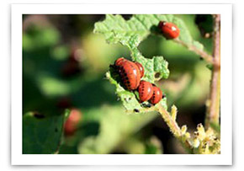
Traditionally, lawn care maintenance is a mixed bag of both harmful chemicals and organically green procedures. Weeding out the most harmful practices and replacing them with environmentally-friendly products is a worthwhile, albeit challenging, pursuit. A study released by the National Academy of Sciences discovered that homeowners use about 10x more harmful pesticides than farmers. In smaller lawns we’re doing more harm to our soil and the environment. Paul Tukey, co-founder of www.safelawns.org, lists a number of pesticides that are not only effective in lawn care maintenance, but also environmentally friendly.
Mosquito & Tick Control | EcoSmart: An herbal combination, this product also works agains mites, crickets, gnats and fleas. Fruit & Vegetable Insect Spray | Dr. Earth: According Dr. Earth, this herbal product blocks insects’ neurotransmitters so they will die quickly; wards against beetles, aphids, and caterpillars.
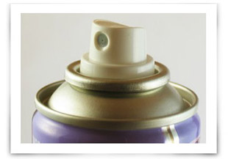
Earth-tone Insecticidal Soap | Esspoma: Apply this product to produce until harvesting; breaks down protective coating of earwigs, whiteflies, and mites.
Bulls-Eye Bioinsecticide | GardensAlive: The manufacturer says that this product is able to target pests, while remaining neutral toward beneficial insects. This works on fire ants, fruit flues and fruitworms.
Beneficial Nematode | Firebelly Organics: Spray on lawn to control white grubs; best to use end of summer in northern states.

